CREATE JAVA APPLICATION

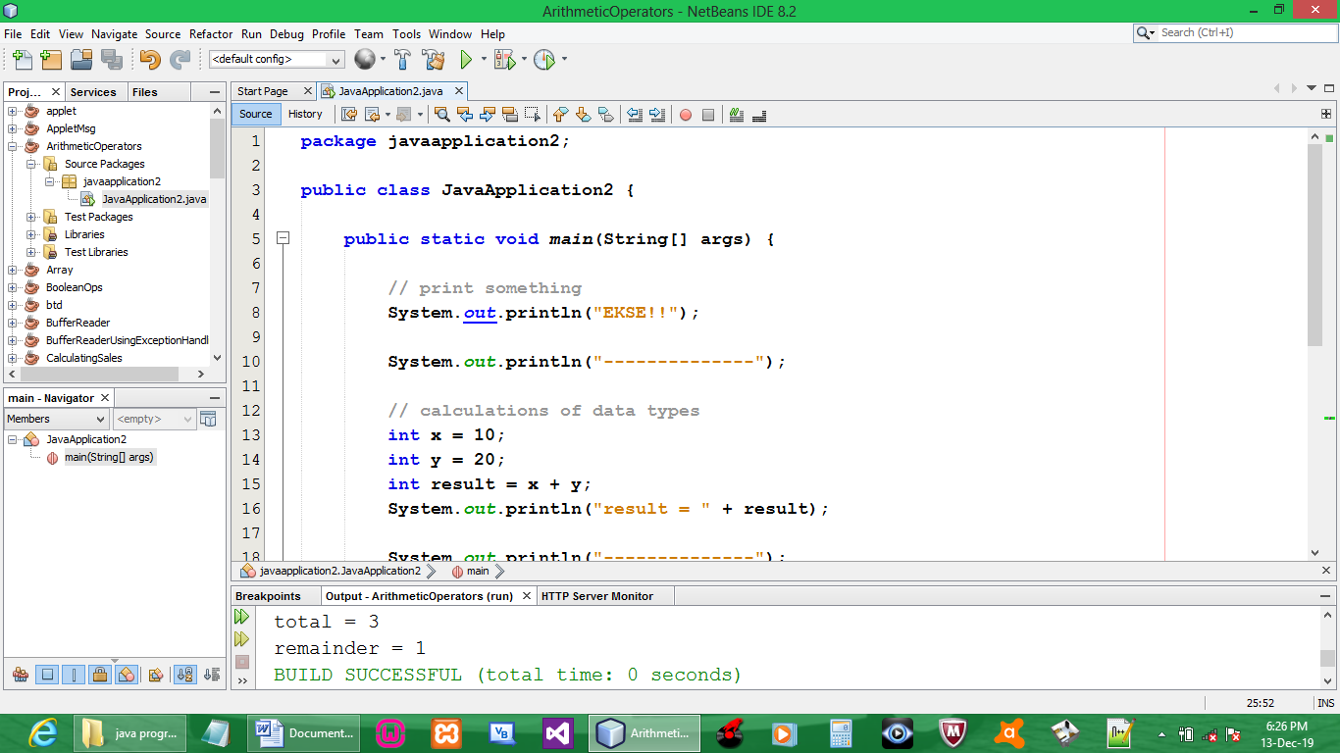

CODE:

package javaapplication2;

public class JavaApplication2 {

public static void main(String[] args) {

// print something
System.out.println("EKSE!!");

System.out.println("--------------");

// calculations of data types
int x = 10;
int y = 20;
int result = x + y;
System.out.println("result = " + result);

System.out.println("--------------");

// modulus(%) ::: remainder
int a = 10;
int b = 3;
int total = a / b;
int remainder = a % b;
System.out.println("total = " + total + "\nremainder = " + remainder);
}

}

OUTPUT:

